Installing HPCC Systems on AWS Platform

- By Skanda P R

**Steps to install**:

1. Create an AWS account.
2. Create the IAM user and add policies.
3. Configure the AWS CLI, EKSCTL, Helm and KubeCTL.
4. Create the EFS service.
5. Create an EKS cluster.
6. Install Amazon EFS CSI driver and external provisioner for Amazon EFS.
7. Deploy the HPCC Systems cluster on EKS.

**Create AWS Account**

Head over to <https://aws.amazon.com/console/> to create an AWS Account.

**Create the IAM user and add policies**

In the Console page, select you account and open “Security Credentials”, which will take you to Identity and Access Management Page. Here you enable the Multi Factor Authentication by using an application like Google Authenticator.

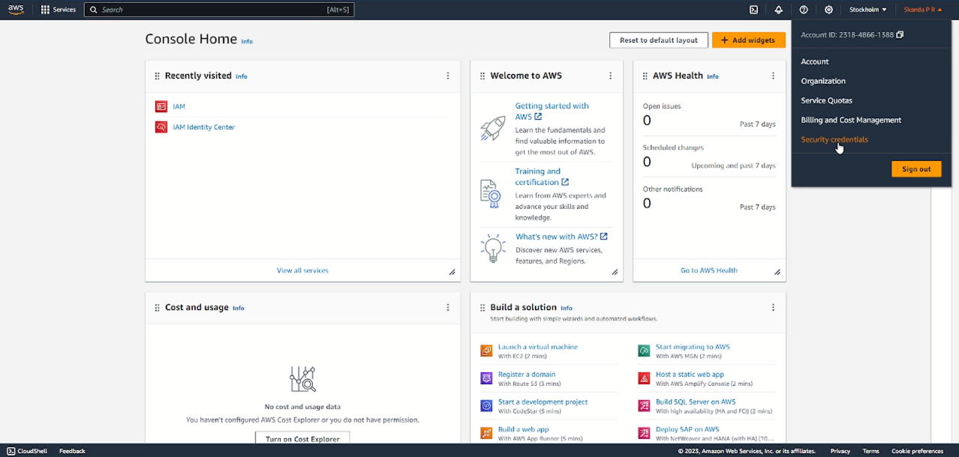

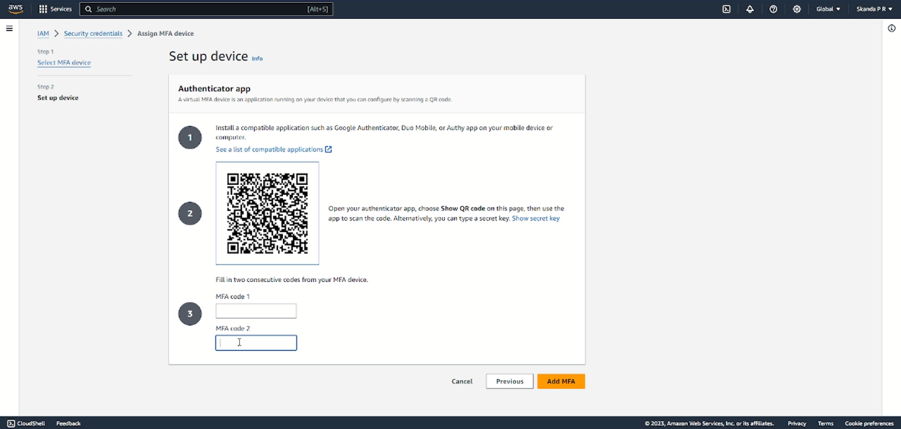

Next, create an IAM user and make a note of the ACCESS_KEY and the SECRET_KEY.

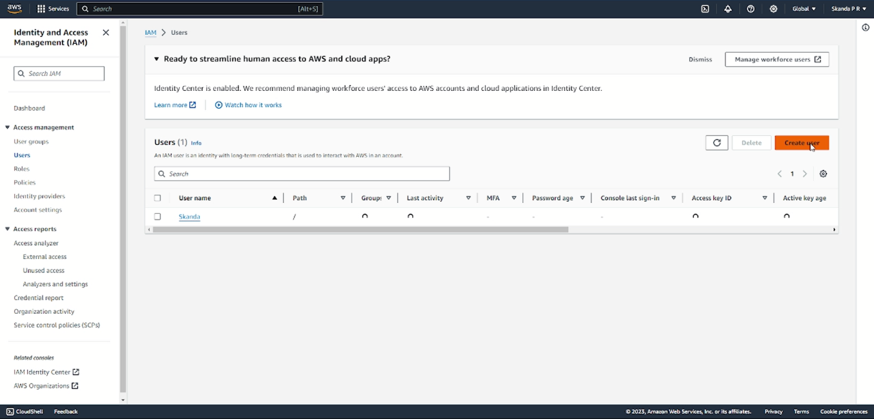

While you are creating the user, add the following policies to the user:

* AmazonElasticFileSystemFullAccess
* AWSCloudFormationFullAccess
* AmazonEC2FullAccess
* IAMFullAccess
* AmazonEKSClusterPolicy
* AmazonEKSWorkerNodePolicy
* AmazonS3FullAccess
* CloudFrontFullAccess
* AmazonVPCFullAccess
* AmazonEKSServicePolicy

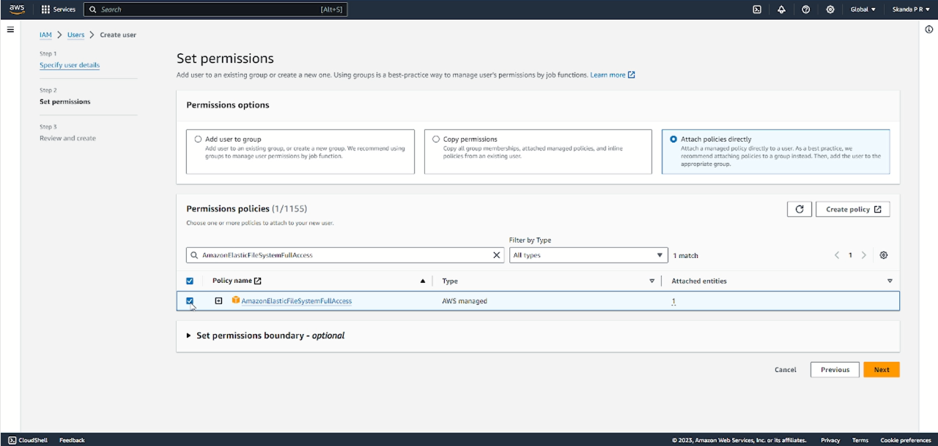

After successfully creating the user, click on the username which you created and click on “Add Policies” and select “Create Inline Policy”. Now in the “Policy Editor” select “JSON” and paste this text:

{

"Version": "2012-10-17",

"Statement": [

{

"Effect": "Allow",

"Action": [

"eks:*"

],

"Resource": "*"

},

{

"Effect": "Allow",

"Action": "iam:PassRole",

"Resource": "*",

"Condition": {

"StringEquals": {

"iam:PassedToService": "eks.amazonaws.com"

}

}

}

]

}

Give any name for the policy and click on “Create Policy”.

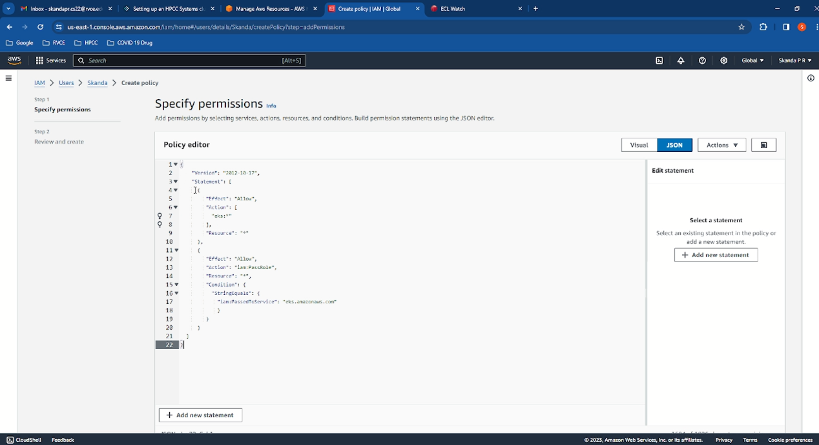

**Configure the AWS CLI, EKSCTL, Helm and KubeCTL**

These tools are prerequisites to install the HPCC System, hence install them by clicking on the provided links and make sure to add all the files related to the tools to the Environment PATH variables.

* AWS CLI v2: <https://docs.aws.amazon.com/cli/latest/userguide/install-cliv2.html>
* Kubectl: <https://kubernetes.io/docs/tasks/tools/install-kubectl/>
* EKSCTL: <https://docs.aws.amazon.com/eks/latest/userguide/getting-started-eksctl.html>
* Helm: <https://helm.sh/docs/intro/install/>

Use this command below and provide the Access Key and Secret Key:

aws configure

**Create the EFS service**

aws efs create-file-system --throughput-mode bursting --tags "Key=Name,Value=<EFS NAME>" --region <REGION>

aws efs describe-file-systems --region <REGION>

aws ec2 describe-vpcs --region <REGION>

aws ec2 describe-subnets --region <REGION> --filters "Name=vpc-id,Values=<VPC ID>"

aws efs create-mount-target --region <REGION> --file-system-id <EFS ID> --subnet-id <Subnet id1>

aws efs create-mount-target --region <REGION> --file-system-id <EFS ID> --subnet-id <Subnet id2>

aws efs describe-mount-targets --region <REGION> --file-system-id <EFS ID>

**Create an EKS cluster**

eksctl create cluster --name profit-3 --region <REGION> --nodegroup-name profit-workers --node-type t3.medium --nodes 3 --nodes-min 1 --nodes-max 4 --managed --vpc-public-subnets <Subnet id1> --vpc-public-subnets <Subnet id2>

eksctl get clusters

kubectl get pods --all-namespaces

**Install Amazon EFS CSI driver and external provisioner for Amazon EFS**

kubectl apply -k "github.com/kubernetes-sigs/aws-efs-csi-driver/deploy/kubernetes/overlays/stable/ecr/?ref=release-1.3"

kubectl get pods -n kube-system

aws eks describe-cluster --name profit-3

aws eks describe-cluster --name profit-3 --query cluster.resourcesVpcConfig.clusterSecurityGroupId

aws efs describe-mount-target-security-groups --mount-target-id <MOUNT TARGET ID1>

aws efs describe-mount-target-security-groups --mount-target-id <MOUNT TARGET ID2>

aws ec2 authorize-security-group-ingress --group-id <ID received in command 5> --protocol tcp --port 2049 --source-group <ID received in command 4> --region <REGION>

git clone <https://github.com/kubernetes-incubator/external-storage>

cd external-storage/aws/efs/deploy/

notepad rbac.yaml

Now copy the contents from my file and paste it in the rbac.yaml file, save and exit.

notepad manifest.yaml

Do the same for this file also but make sure to update the File System ID and Region in the manifest.yaml file.

kubectl apply -f rbac.yaml

kubectl apply -f manifest.yaml

kubectl get pods

kubectl get pvc

kubectl get pv

**Deploy the HPCC Systems cluster on EKS**

helm repo update

helm repo add hpcc <https://hpcc-systems.github.io/helm-chart/>

helm repo list

helm show values hpcc/hpcc > myvalues.yaml

notepad myvalues.yaml

Now copy the contents from my file and paste it in the myvalues.yaml file, save and exit.

helm install mycluster hpcc/hpcc --values myvalues.yaml

kubectl get pods

kubectl get svc

In the final output, copy the External IP Address of ECL Watch which will be similar to this:

aa9ada7e14ae348a7b14e273bf2bf9e3-528934040.eu-north-1.elb.amazonaws.com

Open up a browser and paste this link:

<http://aa9ada7e14ae348a7b14e273bf2bf9e3-528934040.eu-north-1.elb.amazonaws.com:8010>

If everything is working as expected, the ECL Watch page will be displayed as shown:

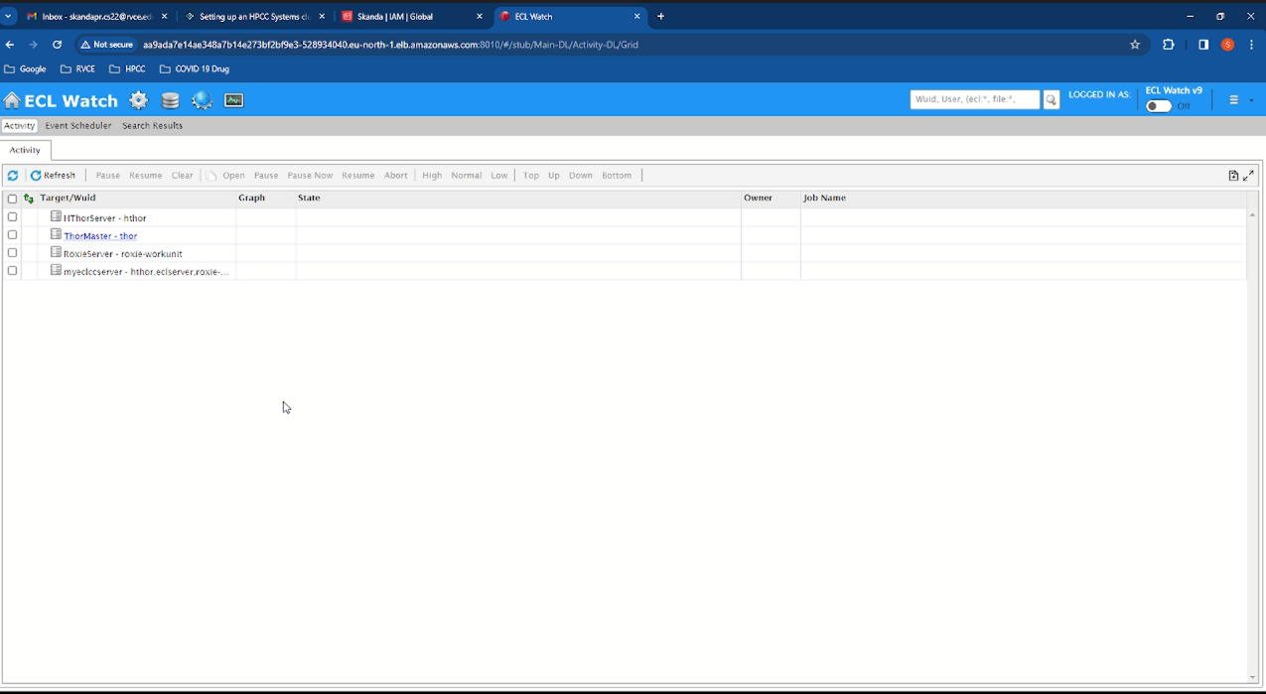

**Uninstall HPCC Systems and EFS Volumes:**

helm uninstall mycluster

kubectl delete pv –all

kubectl delete -k "github.com/kubernetes-sigs/aws-efs-csi-driver/deploy/kubernetes/overlays/stable/ecr/?ref=release-1.3"

eksctl delete cluster profit-3

aws efs delete-mount-target --mount-target-id <mount target ID>

aws efs delete-file-system --file-system-id <EFS ID>

You can also refer to this video for Installation:

<https://youtu.be/tfgxUnJaxVc?si=kHZ3A5blGPx0r3wj>